|  |  |
| --- | --- |
| **ENGLISH** | **TRANSLATION** |
| HEADLINE: Light ahead |  |
| AUTHOR Ole Hansen |  |
| INTRO We see a ray of hope for commodity markets if supply can be significantly reduced. But that remains a big “if”, and if it fails to happen and demand falters, the pain for commodities could last even longer. |  |
| PULL QUOTE “Prices tend to recover much more slowly from a supply-driven downturn than from a demand-induced drop.” |  |
| Commodities spent most of September stabilising after several raw materials, such as industrial metals, hit levels not seen since the beginning of the millennium. Rising supplies of key commodities from metals to energy and crops continued to play havoc with those emerging market countries whose prosperity depends on exports of raw materials. |  |
| The extremely dovish September Federal Open Market Committee meeting highlighted worries about emerging markets. If Federal Reserve chief Janet Yellen worries about the growth outlook for some of the major drivers of commodity demand, especially China, we should as well. |  |
| **No quick rebound** |  |
| Although we do not expect the selloff in commodities to continue, we are unconvinced of a rebound in prices over the coming months as the excess supply across the commodity spectrum is only slowly being reduced. |  |
| As we enter the final quarter of 2015, we see light at the end of the tunnel for commodities assuming that supply is reduced. But if demand fails to keep up, the tunnel could grow even longer, leaving only a glimmer of hope. |  |
| CHART 1 |  |
| The latest spate of weakness was triggered by China’s decision on August 10 to allow the yuan to weaken. This re-ignited fear of a “currency war”, and many EM currencies already under pressure from a rising dollar and the prospect of US interest rates eventually moving higher took another blow. |  |
| Brazil and Russia are now both in recession. They can largely blame the commodity selloff, but internal problems (corruption in Brazil) and external trouble (sanctions against Russia) weigh as well. |  |
| **Oversupply woes** |  |
| Prices tend to recover much more slowly from a supply-driven downturn than from a demand-induced drop as producers often try to make up for the shortfall in revenue by increasing production wherever possible. However, producers in EM countries where currencies have been hit have to a certain extent been shielded from falling commodity prices. |  |
| The current weakness in commodity prices differs from what was seen during the 2008-09 global financial crises when a deep, sharp but short-lived recession triggered a collapse in demand which subsequently recovered fairly quickly. The current weakness has been driven more by rising supply and collapsing investor confidence than by a downturn in economic activity. |  |
| **Hedge fund exposure cut** |  |
| Hedge funds operating in the US commodity futures market collectively have a near-record low exposure to rising commodity prices. While this lack of confidence has helped drive commodity prices to a multi-year low, it also holds the key to the eventual recovery. |  |
| China is currently being steered in a more market-oriented direction. While this will yield plenty of benefits in the longer term, it also makes the economy less manageable in the shorter term. After more than doubling the previous year, the Chinese stock market’s 45% correction since June has raised worries about the demand outlook for the world’s biggest consumer of raw materials. |  |
| But the re-balancing of the commodity markets has begun. In energy markets, we are seeing a slowdown in US oil production, while cheap fuel will help boost global growth and demand. Industrial metals are finding support from producer cutbacks and lower overhang of inventories. |  |
| **Crude oil:** The current weakness in the oil markets, which began more than a year ago and became a rout following the November Opec meeting, has yet to establish a base strong enough to convince market participants that the worst is over. |  |
| Global demand growth has recovered strongly in response to lower prices, but with supply continuing to outstrip demand, the road to normalisation is long. The renewed weakness in the third quarter was driven by an expected pickup in exports from Iran once sanctions are finally lifted in the first quarter of 2016. |  |
| The final quarter of 2015 will be challenging, with refinery maintenance triggering a seasonal slowdown in demand, while recent events in China have sparked (so far) unfounded worries about a slowdown in demand from the world’s biggest importer of crude oil. |  |
| US oil production is slowing, and the Energy Information Administration sees non-Opec output falling next year by the most since 1992. If realised, this will go a long way to stabilise the market during the second half of 2016 and should help oil prices gradually recover back to — and eventually above — levels seen earlier this year. |  |
| While we remain unconvinced that a low in the market has been established, traders should be hesitant to get too bearish, not least considering the aggressive short-covering rally witnessed in August. The road to recovery will be long, which leaves the price upside for the rest of the year capped at $53/barrel on WTI and $55/b on Brent crude. |  |
| TABLE 1 |  |
| **Gold:** While the headlines about gold and silver have been predominantly negative all year, these metals nevertheless remain two of the best-performing commodities on a relative basis. During the past year, the Bloomberg precious metals index is down by less than 10%, compared with around 50% for energy and 26% for industrial metals. |  |
| The so-called “currency war” will continue to attract emerging-market investors and central banks into dollar-based assets, not least from India and China. The Indian and Russian central banks were strong buyers of gold in August, and this has helped the market stabilise amid continued selling from hedge funds and exchange-traded products. |  |
| In a producer perspective, the currency moves are likely to have pushed the marginal cost of production down, leaving producers additional room to operate. On that basis, the eventual recovery in gold hinges on a change in sentiment among paper investors, such as money managers and hedge funds. Most of the third-quarter rallies were driven by hedge funds covering short positions, first after the Chinese devaluation and second after the dovish FOMC statement on September 17. |  |
| The combination of a dovish Fed, uncertainty about China’s currency policy and the health of the global economy as well as low investor involvement may eventually be what triggers or forces a sentiment change. We have argued that the first US rate hike could become a buying opportunity as it would remove the uncertainty that has prevailed for many months. As we still wait for what potentially could be an elusive rate hike, some uncertainty will linger. |  |
| But having seen two robust recoveries within a short period, we sense a change of sentiment is unfolding. Key to this would be a move above gold’s August high at $1,170/oz, which would confirm a floor has been established. We maintain our year-end target of $1,250/oz and only a break below $1,080/oz would bring a change to this outlook. |  |
| TABLE 2 |  |

CHART 1:

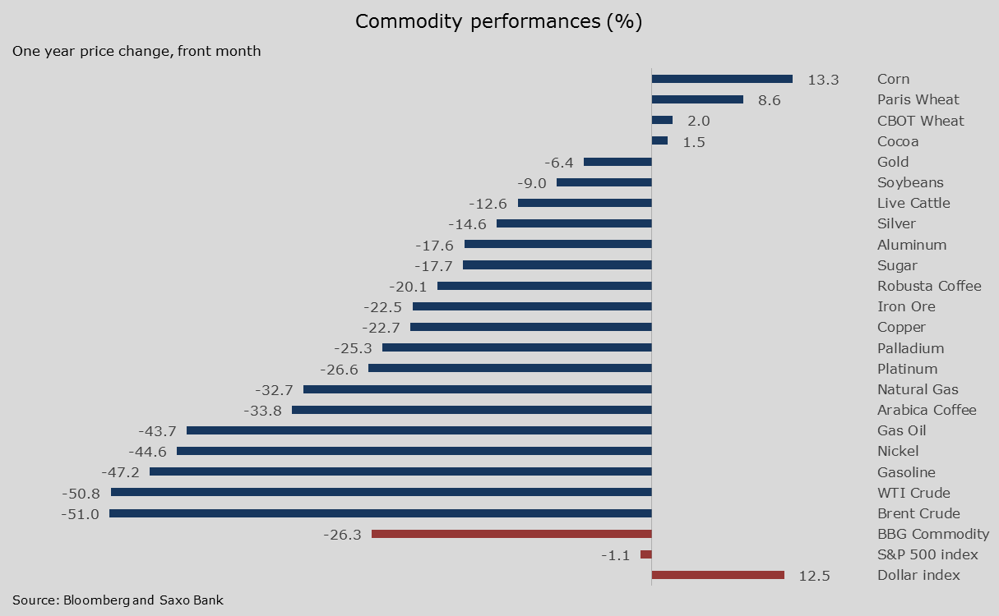

TABLE 1:

|  |  |
| --- | --- |
| **Energy** | |
| **Bull** | **Bear** |
| Non-Opec production, not least US shale, slows faster than expected | Removal of Iranian sanctions triggers a market share battle within Opec |
| Geopolitical instability increases in key producing countries | Global storage capacity exhausted from relentless inventory rise |
| Demand growth gathers pace as a result of lower oil prices | Chinese economic slowdown triggers lower demand for oil |

TABLE 2:

|  |  |
| --- | --- |
| **Precious Metals** | |
| **Bull** | **Bear** |
| Geopolitical events/worries | Dollar reverts back to strength |
| Robust physical demand from central banks | Universally low inflation |
| Fed hikes rates and then pauses as the US economy stalls | Rising real yields raise the opportunity cost of holding precious metals |

#SaxoStrats

Sugar weakness has been prevalent for so long driven by weakness in the Brazilan real, that we’ve almost forgotten to look up. But there is evidence for a prospective move in the sweet stuff especially if El Nino comes out to play. Read more in #SaxoStrats:

https://www.tradingfloor.com/posts/saxostrats-sugar-recovery-well-supported-6275272